Interface with Button

Using the Listener code we worked with last class, add buttons that will retrieve the metric the user has selected.

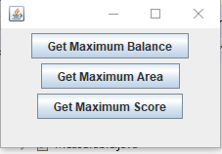

Maximum Account Balance is 513120.0

Maximum Country Area is 513120.0

Maximum Quiz Score is 95.0

Enter metric to use, 1 for maximum, 2 for minimum, 3 for average: 3

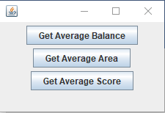

Average Account Balance is 239950.0

Average Country Area is 239950.0

Average Quiz Score is 78.0